Silicon Solution QA Online System Detailed Design Document

Project Document Revision History
Version Number | Date | Revision Author | Description of Revision
1.0 | 07/01/2018 | Derek Dai | Initial Creation

Table of Contents
1. Introduction 1
1.1. Document Outline 2
1.2. Document Description 4
1.2.1. Introduction 4
1.2.2. System Overview 5
2. Design Considerations 5
2.1. Assumptions and Dependencies 5
2.2. General Constraints 5
2.3. Goals and Guidelines 6
2.4. Development Methods 6
3. Architectural Strategies 6
4. System Architecture 7
4.1. Subsystem Architecture 8
5. Policies and Tactics 8
6. Detailed System Design 9
6.1. Classification 9
6.2. Definition 9
6.3. Responsibilities 10
6.4. Constraints 10
6.5. Composition 10
6.6. Uses/Interactions 10
6.7. Resources 10
6.8. Processing 10
6.9. Interface/Exports 11
6.10. Detailed Subsystem Design 11
7. Glossary 11
8. Bibliography 11

Introduction

Document Outline

Here is the outline for the whole detailed design document.
- Introduction
- System Overview
- Design Considerations
  - Assumptions and Dependencies
  - General Constraints
  - Goals and Guidelines
  - Development Methods
- Architectural Strategies
  - strategy-1 name or description
  - strategy-2 name or description
  - ...
- System Architecture
  - component-1 name or description
  - component-2 name or description
  - ...
- Policies and Tactics
  - policy/tactic-1 name or description
  - policy/tactic-2 name or description
  - ...
- Detailed System Design
  - module-1 name or description
  - module-2 name or description
  - ...
- Glossary
- Bibliography

Document Description

Introduction

This document provides the detailed information about the QA online system from the perspectives of functionalities, design, and implementation. We also provide a full instruction in order to help our colleagues to setup the development environment for this project.
This document is for people who want to learn either the overall design or detailed design of the system. Also for those who want contribute to this system.

System Overview
The stations in our Litepoint Lab is built up by individuals, the connections within each station is relatively complex. Currently the detailed information of each station is not recorded neither maintained. It is quit hard for our new colleagues to get familiar with all these stations without the help from our senior engineers. And it also usually takes a long time when someone tries take over a station from another engineer.
The Silicon Solution QA Online System’s main functionality is to provide a solution toward our station and test management problem. Users can easily manage the stations’ and tests’ information.
The system is built on the MEAN stack, that is MongoDB + Express.js + Angular + Node.js. The detailed technique stack information will be introduced in the next chapter.

Design Considerations

Assumptions and Dependencies

Operating System
As for the USER, the operating system does not matter, since users will only interact with the front-end interface through the web browser.

As for the DEVELOPER, we suggest 64-bit version of Windows in Windows 7+. For your information, the system is developed on a DELL laptop with Intel i5-4300M CPU @2.60GHz, 8 GB RAM and 64-bit Windows 10 Operating System.

Software and Tools
As for both USER and DEVELOPER, please use the following to visit the online system:
- Chrome: 67.0.3396.99(64-bit)
- Firefox: 60.0.2 (64-bit)
- IE edge: 42.17134.1.0(64-bit)
The browsers above are utilized to do the functionality tests for the online system. Notice that some features used in our system is not supported by IE edge yet, we suggest using Chrome or Firefox instead in order to gain the best user experience.

As for DEVELOPER, you will need the following tools in order to property set up the development environment:
- Node.js: the back-end system is built based on Node.js(v8.11.2)
- NPM – package management tool: This tool will be installed when you install Node.js. we will use this tool to install Angular CLI, express.js module, etc.
- Angular CLI: Angular development toolkit(v6.0.2)
- Microsoft Visio Studio Code (recommended)
- MongoDB(v3.6.5)

Frameworks and dependencies
As for the front-end application, I used the 6.0.2 version of Angular6 framework, dependencies are shown below. All dependencies are installed and packaged along with the source code. If the dependencies are missing, use “npm install” command in CMD to install all missing dependencies.

"dependencies": {
"@angular/animations": "^6.0.3",
"@angular/cdk": "^6.1.0",
"@angular/common": "^6.0.2",
"@angular/compiler": "^6.0.2",
"@angular/core": "^6.0.2",
"@angular/forms": "^6.0.2",
"@angular/http": "^6.0.2",
"@angular/material": "^6.1.0",
"@angular/platform-browser": "^6.0.2",
"@angular/platform-browser-dynamic": "^6.0.2",
"@angular/router": "^6.0.2",
"angular-feather": "^5.3.0",
"angular-in-memory-web-api": "^0.6.0",
"bootstrap": "^4.1.1",
"core-js": "^2.5.4",
"hammerjs": "^2.0.8",
"ng2-page-scroll": "^4.0.0-beta.12",
"ngx-clipboard": "^11.1.1",
"rxjs": "^6.2.0",
"xlsx": "^0.13.1",
"zone.js": "^0.8.26"
}

As for the back-end application, I used the v8.11.2 version of Node.js framework, dependencies are shown below. All dependencies are installed and packaged along with the source code. If the dependencies are missing, use “npm install” command in CMD to install all missing dependencies.

"dependencies": {
"express": "^4.16.3",
"mongodb": "^3.1.0-beta4",
"multiparty": "^4.1.4",
"nodemailer": "^4.6.7",
"rimraf": "^2.6.2"
}

General Constraints

To use the system, user must have access to the Litepoint intranet. To use the CRUD functionalities, the user must have access to the Litepoint Credential. The older version of browser might not support the technique we used in this project. The server’s storage capacity must be large enough to store all the uploaded files.

Goals and Guidelines
The front end is following mvvm model. The back end is event driven in order to achieve the high concurrency goal.
To quickly start the project, developer might want to save the following commands to batch file. Notice, developer has to install “nodemon" in order to run the batch file.
@echo off
rem database
cd “mongodb bin location”
start mongod.exe
rem Front-end
cd “front end code location”
start /B code .
start "" ng serve -o
rem Back-end
cd “back end code location”
start /B code .
timeout 1
start nodemon --inspect app.js

Development Methods

This system is developed under Agile software development methodology. We quickly developed a prototype of our QA online system and iteratively analyze and improve the system’s functionalities.

Architectural Strategies

Technique Stack
This project is developed by using MEAN stack, which is MongoDB + Express.js + Angular + Node.js.
I utilized the version 6.0.2 of Angular to developer the front-end application. I imported several modules to achieve the final version of the web application. The most important ones are:
- @angular/animation: to implement the animations in web pages like login page, landing page, etc.
- Bootstrap: to apply latest styles to HTML elements in front-end pages
- Rxjs: to utilize functions like takeUntil, subscription, etc.
- Xlsx: to parse the xlsx file
I used the version 3.6.5 of Node.js and version 4.16.3 of express.js to develop the back-end server. I imported several modules to achieve the final version of the back-end application. They are:
- Mongodb: to manage the connection between back-end system and MongoDB
- Multiparty: to parse the incoming POST request with Form-Data
- Nodemailer: to send email notification from back-end server
- Rimraf: to manage files in back-end file system
I used the version 3.6.5 of MongoDB to store the data. Notice detailed data structure will be described later.

User Interface Paradigms
The whole online system uses a consistent color theme, which is consist of orange and black. For example:
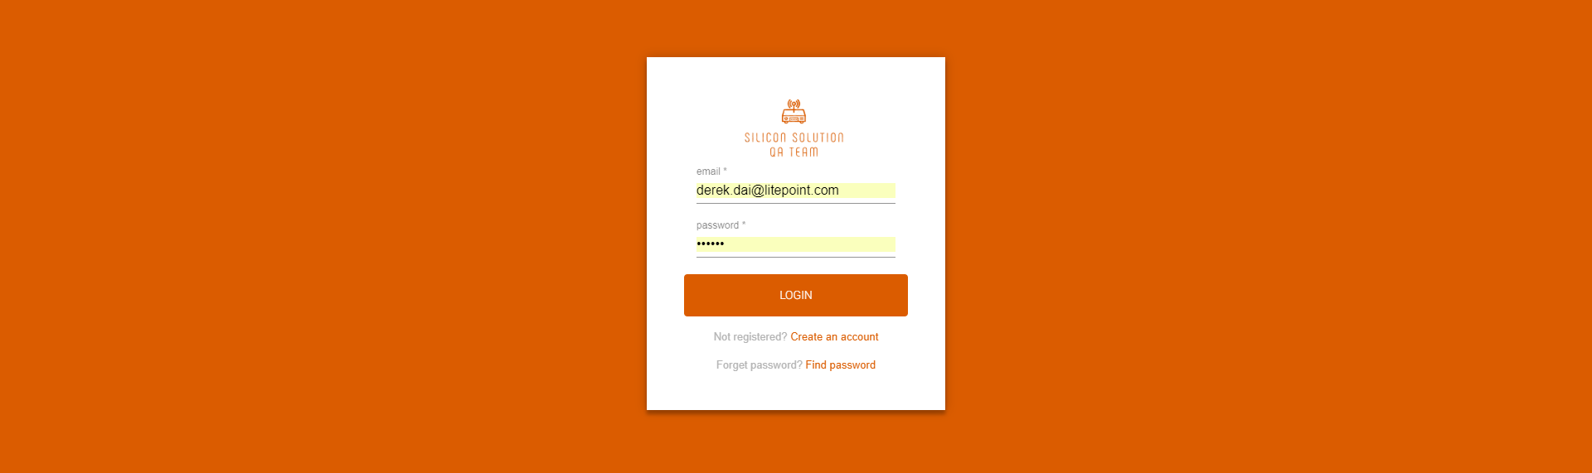


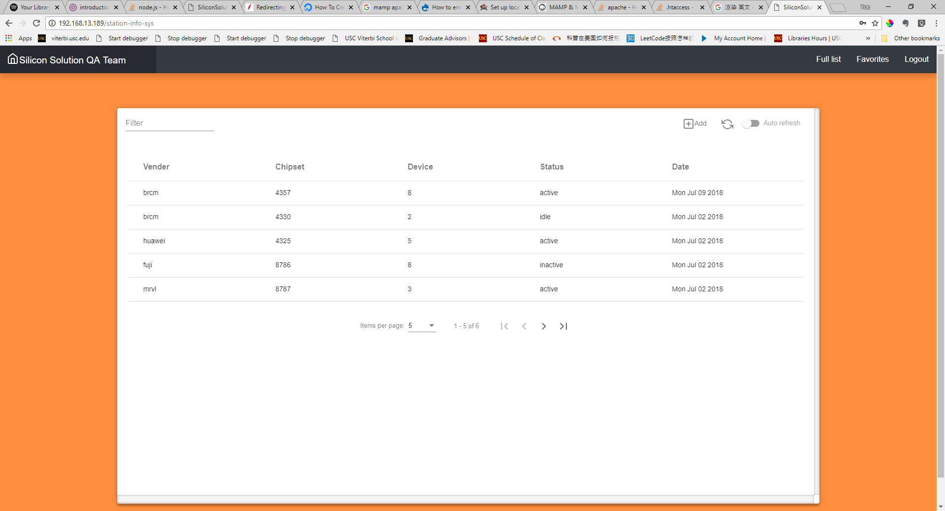
The styles of components in online system are based on Angular Materials style and Bootstrap4. The Landing Page is built with Big Picture and Parallax web design, which are pretty popular these days.

External Data Storage
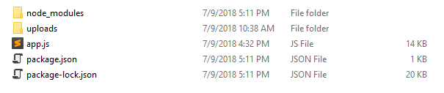
Besides MongoDB, we use File System to store uploads from front-end application, such as station connection picture, DUT connection picture and all documents related to corresponding station. All these uploads are stored in the folder named “uploads”, insides the “uploads” folder, each station has its own folder whose name is the station’s name, like brcm-4357-4UP.
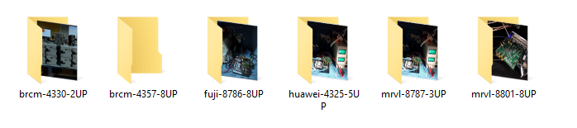

Communication Mechanisms
The communication between front-end application and back-end server is through HTTP GET request and POST request, which are sent via AJAX. The Asynchronized feature does not block the web page brings the best user experience toward our colleagues. Furthermore, as for the login part, the back-end server utilizes LDAP protocol to communicate with our Litepoint credential server.

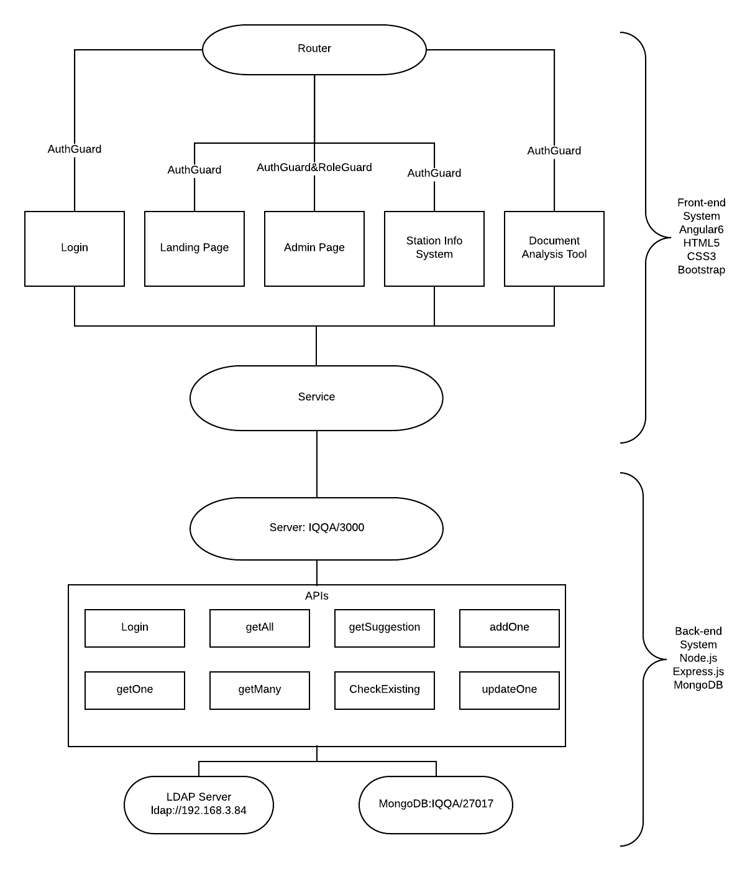
System Architecture

Now let’s go through the high-level overview of how the functionality and responsibilities of the system were partitioned and then we will go a little bit deeper into each subsystem.
The whole online system is consisting of two basic and large components, front-end application and back-end application. We use AJAX to connect these two components together. The back-end app listens on port 3000, connect with Litepoint’s LDAP server and MongoDB which listens on port 27017. The Front-end app uses HTTP GET and POST request to send and retrieve data.
As for the Angular APP, I used Angular Router to navigate user toward different component within the system, they are login component, Landing Page component, Station Info Component, Document Analysis component. Notice, the current system only have one forRoot router and only one NgModule which is the root module. If the system is getting larger in the future, we can use feature modules with dedicated router for each one of them. Furthermore, all these components mentioned above interact with the service component. The service component takes care of all the data communication work, the other components can then focus on rendering and collecting data. More detailed information will be shown in the next chapter.
From the perspective of back-end, the server application listens on port 3000, it provides Restful APIs toward our front-end system. They are login, getMany, getAll, getSuggestion, addOne, getOne, checkEsiting, updateOne. All these APIs are generalized. For example, you can use getOne to retrieve data record from any collections (will introduce soon) by providing required arguments, such as collection name.
The LDAP Server is the Litepoint Credential Server. We use it to check user’s login information.
The MongoDB which listens on port 27017 contains three collections, userInfo, stationInfo and testInfo. userInfo stores all the information about each user, stationInfo collects all the information of stations in our Litepoint Lab, testInfo maintains the latest testing result and related data.

Front-end Application
The Router Module enables navigation form one view to the next as users perform application tasks. It can interpret a browser URL as an instruction to navigate to a client-generated view. Furthermore, it can pass optional parameters along to the supporting view component. The code below shows the mapping between URL and our components.

const routes: Routes = [
{ path: '', redirectTo: 'login', pathMatch: 'full'},
{ path: 'login', component: LoginPageComponent},
{ path: 'home', component: HomePageComponent},
{ path: 'station-info-sys', component: InfoSysComponent, data:stationInfoConfig},
{ path: 'location', component: LocationPageComponent},
{ path: 'xlsx', component: ExcelVisualizationComponent},
{ path: '**', component: NotFoundPageComponent}
];
Our implementation of router also takes charges of passing configuration toward components like Station Info System. This is related to the detailed design of our Info System component. Notice, the front-end application is currently run on Apache server, to enable the router features, you have to set the AllowOverride in httpd,conf file from None to All, and add the .htaccess file in the htdocs folder. The .htaccess file should include the following code

RewriteEngine On
# If an existing asset or directory is requested go to it as it is
RewriteCond %{DOCUMENT_ROOT}%{REQUEST_URI} -f [OR]
RewriteCond %{DOCUMENT_ROOT}%{REQUEST_URI} -d
RewriteRule ^ - [L]

# If the requested resource doesn't exist, use index.html
RewriteRule ^ /index.html

Furthermore, our Router is protected by two guards, AuthGuard and RoleGuard that implements the canActive interface. The AuthGuard checks whether the user has logged in or not, it protects the system from visitor outside the company. The RoleGuard check user’s privilege.
As for the Services component, it provides generalized communication functions toward all other components. Take “getAll” function for example, it will create a POST request based on the given parameters. The getAll’s prototype is “getAllStations”, however I then found that this kind of functions can be re-used in the future development. Such as retrieving all records from Test Status collection from database. So I generalized all communication functions in Services component. All the functions in Service component returns an Observable Object, which is the best practice in Angular2+.

getAll(collection: string): Observable<any[]>{
return this.http.post<any[]>(this.getAllUrl, {
collection: collection,
option: {
_id: 0, id: 1, vender: 1, chipset: 1, device: 1, status: 1, update_time: 1
}
}, this.httpOptions);
}

The Service component imports the Angular Injectable symbol and annotates the calss with the @Injectable decorator. This marks our QaSysService class as one that participates in the Dependency Injection(DI) system. Almost all the other component objects depend on the Service component, since we registered the Service component in the DI system, it will supply the dependent objects when it creates an instance of an object, like Login page object
The Landing Page utilizes HTML5 and CSS3 to implement the Big Picture and Parallax web page design.
The Document Analysis component is a pure front-end application, it does not communicate with the back-end, it parses XLSX files, sort them, and converts them into JSON data. It provides analysis and charts functionalities toward users, User can use the analysis functionality to analyze the differences between input files, the system can show the most recent updates, deletes and insertions, it can also show records that has not been updated in the most recent four files. The charts functionality collects historical actions, categorizes them into three groups (updates, insertions, deletes), and then show all the historical data in charts.
The Station Info System is actually built with Info System component and configurations for station info system. The Info System component is generalized, it reads the configuration sent via Router parameters, read the corresponding data from back-end. During the implementation of station info system, I found that the Station Info System and all other info system application that we may implement in the future requires the same functionalities that are Create, Read, Update, and Delete, aka. CRUD. By generalizing the Info System component, we can easily build up another info system in seconds by passing different configuration. The configuration for station info system is shown below
const stationInfoConfig = {
briefInfo: StationInfoBrief,
fullInfo: Station,
dialog: DialogPageComponent,
bottomSheet: BottomSheetComponent,
collection: "stationInfo",
tableColumns: [
{ columnDef: 'vender', value: "vender", header: 'Vender', cell: (element: any) => `${element.vender}` },
{ columnDef: 'chipset', value: "chipset", header: 'Chipset', cell: (element: any) => `${element.chipset}` },
{ columnDef: 'device', value: "device", header: 'Device', cell: (element: any) => `${element.device}` },
{ columnDef: 'status', value: "status", header: 'Status', cell: (element: any) => `${element.status}` },
{ columnDef: 'update_time', value: "update_time", header: 'Date', cell: (element: any) => `${(new Date(parseInt(element.update_time))).toDateString()}` },
],

pageDataSource: new MatTableDataSource<StationInfoBrief>(),
fullDataSource: new MatTableDataSource<StationInfoBrief>(),
favoriateDataSource: new MatTableDataSource<StationInfoBrief>(),
}
As you see, the dialog and bottomsheet attribute are dedicated component, that is because different info system might require different operations and consist of different kinds of detailed information.

Back-end Application
The back-end application is much simpler, it consists of two parts, Node.js application and MongoDB.
In the Node.js application we use Express.js framework, based on that we create nine general APIs:
- the login API gather user’s input and send them to Litepoint Credential Server, check user’s role in Online System’s database, send the result back to front-end
- the getAll API retrieves all records in corresponding collection;
- the getMany API retrieve records with specific criteria
- the getOne API retrieves one record from corresponding collection that matches the given criteria;
- the addOne API add new record to the corresponding collection
- the updateOne API update one record in the corresponding collection that matches given criteria;
- the getSuggestion API retrieves all distinct values in certain fields in the corresponding collection
- the checkExisting API checks whether certain value exists in the corresponding field in certain collection
The login component used to retrieve verification info from the old login API, user can register and retrieve password. But later we decided to use Litepoint credential service to login, so that user do not need to register and they won’t forget the password. So we immigrate from the old login API toward the new one and abandoned the register and password retrieving APIs. The new login API calls the remote Litepoint LDAP server with ldap-client module, if the response is positive, it looks into the database, retrieve the role information and send all information together back to Angular application. The database now stores username, email and role information for reference.

Front-end Detailed System Design

Landing Page Component
The landing page is the most intuitive component on the front end, it is a simple static web page with big picture and parallax design by using HTML5, CSS3 and Bootstrap. The source code locates at “front-end/src/app/home-page” folder.
This page navigates user to different systems. To modify this part simply update the corresponding <div>, take the station-info for example:
<div class="team-info" [@showUp] = "state">
<div class="team-intro">
<h1>
THE <br/>
SILICON <br/>
SOLUTION <br/>
QA TEAM <br/>
</h1>
<p>
WHAT WE DO
</p>
<input type="button" value="Learn More">
</div>
<div class="parallax team-img"></div>
</div>
</div>
This component contains two animations, the first one is flyInOut affects the navigation bar on top of the web page, the other one is showUp affects the team-info part

Station Info Page Component
In contrast to the previous component, this station info page component is the most complex one on the front end. It consists of System Info page component, bottom sheet component, dialog component, and test status component. We will go through them one by one below

System Info Page Component
This component locates in “front-end/src/app/info-sys” folder. It shows brief information of certain records, for example the station info. It provides CRUD functionalities toward privileged users with the help from bottom-sheet and dialog component.
At the beginning of the project, we wanted to implement two info systems, one shows station info, the other one provides test status info. Since the only differences between these two system would be the data, I decided to create a reusable component, by passing different data and other parameters we can quickly generate two different info systems. However lately we changed our mind to merge the test status system into the station info system, because this can bind test status to their corresponding station. So the current system info page is only used for station info system, but it might be re-used in the future for new information system. Notice that some of the design below is for the station info system.
The system info page reads configuration data from the router, it retrieves brief info data from the back-end and display them in the table. The table itself provides sorting, filtering and refreshing functionalities. For detailed implementation please refer to the corresponding code in the component. Click on the Add button will trigger the dialog component with new record info. Click on certain row in the table will trigger the bottom sheet component and based on the result returned from bottom sheet component it will call the dialog component for detailed info/info update, add the selected row into favorite list, or delete the station.
By adding the record into favorite list, the component will store these record into localStorage, whenever the user re-enter the system with the same browser, he or she can easily access to the records he/she interested in. And of course, the user can un-favorite the records. The favorite list and the full list using the same table component with different data.
By deleting the record especially station info will remove the record and all related info from both database and file system in the back-end system. As for the station info, the back-end will also remove all test status related to it.
Detailed design, like paginator, sorting, filtering, etc, please refer to the source code.

System Info Page Component
This component locates in “front-end/scr/app/bottom-sheet” folder.

Testing

Glossary

An ordered list of defined terms and concepts used throughout the document.

Bibliography

A list of referenced and/or related publications.

Brad Appleton <brad@bradapp.net>
http://www.bradapp.net

